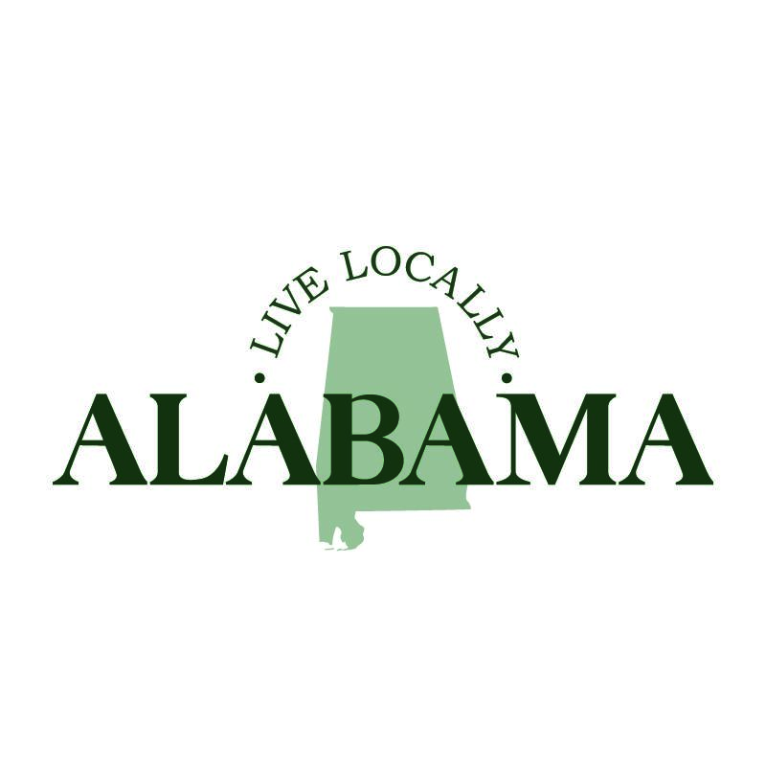

**FOR IMMEDIATE RELEASE**

DATE: Month day, 2024

MEDIA CONTACT: name

Xxx phone number

xxx email

**Live Locally Alabama**

*A Quality-of-Life Campaign Led by the Municipal Leaders of Alabama*

As (mayor/ town administrator) of (fill in city or town here), I am thrilled to support Live Locally Alabama, a quality-of-life campaign spearheaded by the Alabama League of Municipalities on behalf of local leaders. This initiative was developed to enhance the well-being of our communities by focusing on essential aspects such as public safety, infrastructure improvements, economic investment, education, workforce development, supporting local businesses and the many cultural and recreational activities available in the beautiful state we call sweet home Alabama.

Our state currently has 465 cities and towns ranging from towns of 100 residents to cities topping one hundred thousand. Some cities and towns are older than the state itself while others are in their first decade of incorporation. While the most urban areas have the largest populations, over 42% of Alabamians live in rural communities, according the 2020 U.S. Census. Alabama is also one of the most biodiverse states in the nation, with a landscape that features white sandy beaches along the Gulf of Mexico to unbeatable views and hiking trails along the Appalachian Mountains. All of this, along with our amazing citizens, equates to making Alabama a great place to live, work, play and raise a family.

As an elected official, I understand the importance of investing in our local communities to lay the groundwork for a more prosperous future for Alabama. After all, local government serves as the foundation for Alabama’s economy. Local government is the closest to the people, and I am proud to join local officials across the state to ensure every Alabamian has the opportunity to lead a fulfilling life. Local government is at the forefront of this initiative as we work together to improve infrastructure and focus on intentional growth and development that preserves our beautiful natural resources and promotes a healthier lifestyle. (add specific examples related to your community)

I want to encourage all citizens to get involved with our community and to support Live Locally Alabama. Shop locally at our stores, eat locally at your favorite restaurants, learn locally by taking your kids to a museum nearby and play locally at one of our parks. Attend a local council meeting, engage with community initiatives and improvement projects and follow our social media pages to stay up-to-date with our latest activities and plans. This is a community effort and your insight and participation in local government is invaluable as we strive to tailor improvements to best meet the needs of our community. Together we can continue to make Alabama an incredible state to live in and create a robust future for generations to thrive.

Learn more about Live Locally Alabama at: <https://almonline.org/LiveLocallyAlabama.aspx>.

###